

**Progress Report**

**Fall 2015-2016**

**Team Number ECE-BCC-4**

**Project P.E.T.E.R.S.**

**Team Members**

|  |  |  |  |
| --- | --- | --- | --- |
| **Name** | **Department** | **Email** | |
| Richard Taylor  Anthony Schmidt  Kenneth Hale  Antonio Foster  Brett Reich | ECE  ECE  ECE  ECE  ECE | [rrt36@drexel.edu](mailto:rrt36@drexel.edu)  [ajs469@drexel.edu](mailto:ajs469@drexel.edu)  [kch44@drexel.edu](mailto:kch44@drexel.edu)  [af558@drexel.edu](mailto:af558@drexel.edu)  [br382@drexel.edu](mailto:br382@drexel.edu) | |
|  |  | |

**Team Advisor(s)**

|  |  |  |
| --- | --- | --- |
| **Name** | **Department/Company** | **Email** |
| Christopher Peters | ECE | cpeters@coe.drexel.edu |
|  |  |  |
|  |  |  |

**Group Leader's Signature : ____________________________**

**Advisor's Signature : ____________________________**

**\*\*\*\*\*\*\*\*\*DELETE THIS SECTION\*\*\*\*\*\*\*\*\*\*\*\*\*\*\*\*\*\***

**Format**

* **Single spaced, Times New Roman (Body - 12, Headings and sub-headings - 14), Justified.**
* **Start each section on a new page**
* **Submit as a PDF to ece-sd-2015@drexel.edu and four stapled hard copies (two sided) to the box in ECE Office in front of Tanita's Desk**

**\*\*\*\*\*\*\*\*\*DELETE THIS SECTION\*\*\*\*\*\*\*\*\*\*\*\*\*\*\*\*\*\***

**1. Abstract**

**\*\*\*\*\*\*\*\*\*DELETE THIS SECTION\*\*\*\*\*\*\*\*\*\*\*\*\*\*\*\*\*\***

Ko

**Concise summary of the importance of the problem, objectives of the project, proposed methods of solving the problem or of seeking a solution to the problem. The abstract should not exceed half a page.**

**\*\*\*\*\*\*\*\*\*DELETE THIS SECTION\*\*\*\*\*\*\*\*\*\*\*\*\*\*\*\*\*\***

**Table of Contents**

**List of Figures**

**2. Problem Description**

**\*\*\*\*\*\*\*\*\*DELETE THIS SECTION\*\*\*\*\*\*\*\*\*\*\*\*\*\*\*\*\*\***

**Provide a general background to the problem you are proposing to solve. Establish the need for a solution to this problem.**

**\*\*\*\*\*\*\*\*\*DELETE THIS SECTION\*\*\*\*\*\*\*\*\*\*\*\*\*\*\*\*\*\***

**3. Proposed Work and Deliverables**

**3.1 Solutions considered**

Our focus of the project is clear. Obtain and modify hardware capable of communicating and acquiring external data, while displaying the information clearly to the user in a paintball match. This is however only half the battle. It was evident that external hardware (Raspbery Pi) would be necessary for networking and paintball marker data collection. This device would then push the information to the chosen display device. In order to begin the project we needed a suitable H.U.D. (Heads up Display).

**3.1.1 Hardware**

**1.** Google Glass – The group’s original idea centered focus around what is known as “Google Glass.” A headset designed to be worn like glasses in everyday life and accomplish a variety of useful tasks such as taking pictures or navigating directions. The system utilizes a projector to reflect the transparent screen back to the user. This system was very ideal because it is open source and many people have experimented on it already. Unfortunately, due to it unpopularity Google decide to shut down its “Google Glass” program for the time being.

**2.** GlassUp – An alternative choice to google glass was a monochromatic heads up display that displayed only important data for the user. Working in a similar fashion it projected and image back to the user for everyday use. It was decided that this pair of glasses would not give us the image we required to make an enjoyable paintball HUD.

**3.** **Recon Snow2** – A brand new product created for specifically for the purpose of alpine sports. This wearable heads up display includes a GPS sensor, accelerometer, Bluetooth, and full color screen running android. The perfect solution to fit our project needs.

**3.1.2 Software**

**3.2 Unique Principles**

We believe choosing the Recon Snow2 was the correct solution to our problem based on the open source versatility of the HUD. By utilizing the equipment's built in GPS, accelerometer, Bluetooth, and screen we are able to cut down on the amount of hardware needed to succeed, and focus more specifically on the software needed to achieve our goals.

Also supplied by Recon is the library they used to create software for the HUD. This is extremely beneficial and will be incorporated into our overall solution.

**3.3 Existing Systems**

Currently on the market the closest thing we could find to meet our goal is the Recon Snow2. No other company or person has yet developed a heads up display specifically for paintball. We will utilize as much technology from the Snow2 as much as possible but are forced to use external hardware (Raspbery Pi) for a complete solution.

**3.4 Criteria for Acceptable Solution**

We feel in order for this to be an acceptable solution, the final product must provide the following services.

1. Allow player to view his location and direction, and team location on a map of the field of play.

2. Warn the user when the amount of air in the tank has hit a critical point

3. Warn the user if a nearby team member has critical air in their tank

**3.5 System Flow Diagram**

Rick?

**4. Completed Work**

**4.1) Hardware –**

1. All necessary hardware purchased and obtained (See Section 7)

2. Pressure sensor location decided and mounted

3. Captured and graphed Pressure data for paintball marker.  
  
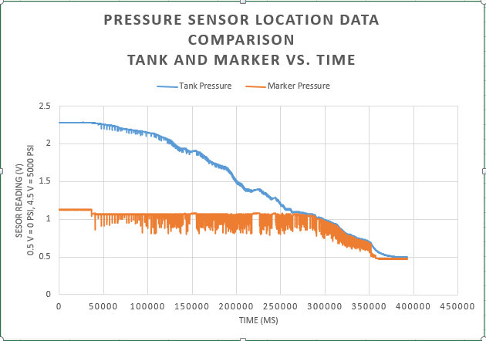

**Figure #. Data Collected from Pressure Sensor**

4. Analysis of USB power bank for Raspbery PI

**4.2) Software**

Rick Brett?

**5. Work Schedule / Proposed Timeline**

**\*\*\*\*\*\*\*\*\*DELETE THIS SECTION\*\*\*\*\*\*\*\*\*\*\*\*\*\*\*\*\*\***

**This is the proposed timeline for your project and should convey when various phases of the design cycle are planned to begin and end. It is recommended that you generate your timeline using project management software with the full intension of abiding by the internal and external deadlines that are dictated by such a schedule.**

**Provide this information in the form of a Gantt Chart.**

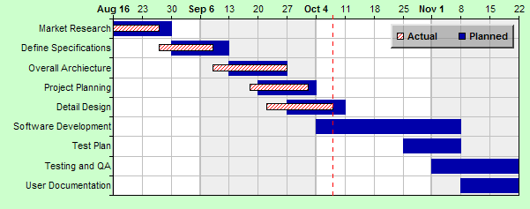

**textbook Chapter 3**

**\*\*\*\*\*\*\*\*\*DELETE THIS SECTION\*\*\*\*\*\*\*\*\*\*\*\*\*\*\*\*\*\***

**6. Industrial Budget**

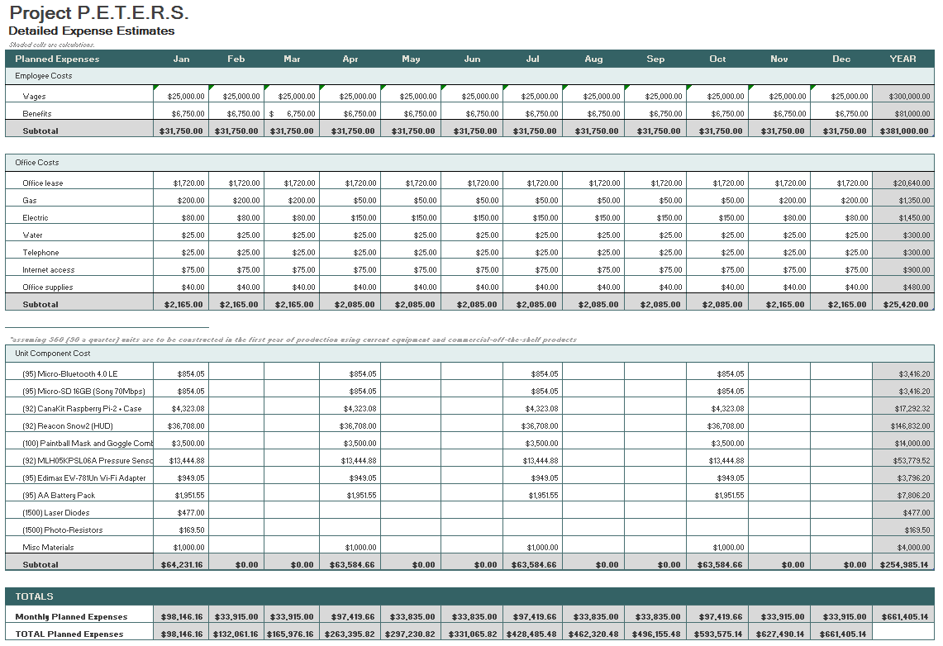

**7. Out-of-Pocket Budget**

|  |  |  |  |
| --- | --- | --- | --- |
| **Model Name** | **Unit Cost** | **Units** | **Sub-total** |
| AA Battery Pack | $19.49 | 2 | $38.98 |
| Micro-Bluetooth 4.0 LE | $8.99 | 2 | $17.98 |
| Micro-SD 16GB (Sony 70Mb/s) | $8.99 | 2 | $17.98 |
| CanaKit Raspberry Pi 2 + case | $46.99 | 2 | $93.98 |
| SNOW2 (HUD only) | $399.00 | 2 | $798.00 |
| MLH05KPSL06A | $146.14 | 2 | $292.28 |
| Photo-Resistor (20pcs) | $4.69 | 1 | $4.69 |
| SNOW2 (HUD + Goggles) | $549.00 | 1 | $549.00 |
| White LED 5mm (25pcs) | $3.54 | 1 | $3.54 |
| Edimax EW-7811Un Wi-Fi Adapter | $9.99 | 2 | $19.98 |
| Female / Male / Male 1/8th | 36.47 | 1 | $36.47 |
| shipping (for goggles) | $54.99 | 1 | $54.99 |
|  |  | Total | $1,927.87 |
|  |  | Per Person | $385.57 |

**8. Societal, Environmental or Ethical Impacts**

This project is being designed with the hope of having a big societal impact. We are currently living in a time when programmers and engineers are constantly looking for an opportunity to improve the way people interact with one another. This project is another way of exploring these opportunities. The way we use data is constantly evolving and more and more everyday experiences are being improved upon through the use readily available technology. The P.E.T.E.R.S. is being developed with this very idea in mind. By taking a game that has seen little change in the way it is being played since its inception and adding new dimensions through the use of sensor data acquisition, the latest in available heads up display technology, and the open source nature of Android software, we hope to elevate the game of paintball in a way that brings a portion of the gaming community into the paintballing community. Part of what attracts gamers to the first-person shooter genre of gaming is the competition, the left-brain satisfying stat-tracking capabilities, and the strategic aspects of the game that make a player successful. P.E.T.E.R.S. looks to take all of these aspects and bring them to the live action of paintball. This would potentially get more people out of the house and being more active, while simultaneously drastically changing a billion dollar industry worldwide.

The ethical and environmental impacts of this project are virtually non-existent. An argument could possibly be made that the game of paintball is protecting the environment if effecting it at all. The more popular the game of paintball becomes, the more paintball playing fields that will be needed to support the growth in participants. A paintball field does not require irrigation so no water is being used for upkeep, as there is in the upkeep of a golf course. The layout of the land is generally undisturbed as well, thus preserving the habitat for any wildlife inhabiting the area. **9. Summary/Conclusions**

Paintball is a billion dollar industry worldwide but the game itself has seen little change in technology over the past 30 years. By applying scientific concepts, the popularity of microcontrollers, and our own experience we have found a way to improve it. This new advanced version of paintball will allow players to feel more connected to the game and physically change the game dynamic. By changing the game to be more videogame like we can attract a whole market of people who never have thought to play paintball. The bottom line is creating a heads up display system for paintball can be very profitable.

In just one quarter our team has managed to obtain all the necessary hardware needed for at least two independent systems. We have established the feasibility of obtaining pressure data and relaying the information. Backbone networking code has been created for seamless communication. As well as GUI interface code has begun to display the information for the user. By attacking this project from all sides systematically, we are able to work efficiently and effectively. The majority of the next quarter our team will focus on GUI development, networking, and hardware placement.

**10. References**

**\*\*\*\*\*\*\*\*\*DELETE THIS SECTION\*\*\*\*\*\*\*\*\*\*\*\*\*\*\*\*\*\***

**Please adhere to the IEEE citation style. This does not count against the 15 page limit.**

**\*\*\*\*\*\*\*\*\*DELETE THIS SECTION\*\*\*\*\*\*\*\*\*\*\*\*\*\*\*\*\*\***

**Appendix A: Design Constraints Summary**

Team Number: ECE-##

Project Title:

Summary of the Design Aspects:

**\*\*\*\*\*\*\*\*\*DELETE THIS SECTION\*\*\*\*\*\*\*\*\*\*\*\*\*\*\*\*\*\***

**One to two paragraphs summarizing all design aspects of the project. This includes hardware, software, testing protocols, lesson plans, etc.**

**\*\*\*\*\*\*\*\*\*DELETE THIS SECTION\*\*\*\*\*\*\*\*\*\*\*\*\*\*\*\*\*\***

Design Constraints:

Economic:

This project has proven to have a rather high initial cost of design due to the use of commercial-off-the-shelf products. For proof of concept this was an acceptable scenario. If this product were to be mass produced, many of the components could be designed and developed for the intended purpose of the overall system which would save on the cost of production making it a much more likely venture for financial gain.

Manufacturability:

In the design of this product we are limited by the tools and machinery that we have access to. The main challenge is taking two components of the design that were never meant to be integrated, and integrating them. This would be easier with the proper material processing equipment or access to a wider variety of tools. In the process of building a prototype design these kinds of shortcomings can be expected and are being dealt with as best as possible.

Sustainability:

This project will rely on our ability to provide power to the system for the duration of playing paintball for what could conceivably be most of the daylight hours. The power used to keep the system going must be able to handle a possible 6-8 hours of gameplay, and at the same time not be too cumbersome as to hinder the players movement around the field of play.

Environmental:

Ethical, health, and safety:

Social:

Political:

Standards and Regulations

**\*\*\*\*\*\*\*\*\*DELETE THIS SECTION\*\*\*\*\*\*\*\*\*\*\*\*\*\*\*\*\*\***

**Cite list of Standards/Regulations that were used or evaluated for the project (use**

**IEEE Reference-style). Make sure you understand why a certain standard is to be met by your project, you will be questioned regarding this during your presentation. Don't simply mention random standards and regulations without studying their uses and requirements.**

**\*\*\*\*\*\*\*\*\*DELETE THIS SECTION\*\*\*\*\*\*\*\*\*\*\*\*\*\*\*\*\*\***

**Appendix B: Resumes**

**\*\*\*\*\*\*\*\*\*DELETE THIS SECTION\*\*\*\*\*\*\*\*\*\*\*\*\*\*\*\*\*\***

**Provide one page resumes for each of the students.**

**\*\*\*\*\*\*\*\*\*DELETE THIS SECTION\*\*\*\*\*\*\*\*\*\*\*\*\*\*\*\*\*\***